CS3600 Spring 2021 **HW 2 -3600 Operating System**

**Submit your answers in Canvas as a pdf document on or before (02/20/2021).**

Answer the below questions ( 1 and 2) by giving a search using Google **(1 points)**

1. Parent of all processes in UNIX OS is __init process____.

2. Parent of all App Processes in Anroid OS is ___init process (zygote)_____ .

3. Consider a parent process that has forked a child in the code snippet below.

**int count = 0;**

**ret = fork();**

**if(ret == 0) {**

**printf("count in child=%d\n", count);**

**}**

**else {**

**count = 1;**

**}**

The parent executes the statement ”count = 1” before the child executes for the first time. Now, what is the value of count printed by the code above?Justify your answer. **(4 points)**

“Count in child = 0”, when ret == 0, we are looking into the child process and it duplicates the parent’s data which prior was 0. Child shows first then can change after the next cycle or sleep before the printf.

4. Write a c program to implement threads. Accept an array of 40 integers, write a thread method named sum of array elements. Divide the array into 4 equal elements and call threads to find the sum of each part. Store the sum in a variable called ‘arrays’ . Print the sum in the main function. **(8 points for prohram and 2 points for screenshot of output)** 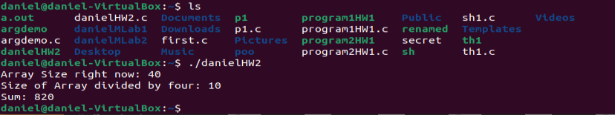

**What to turn in Canvas:**

**Submit answers from Q1 to Q3,screenshot of Q4 in a pdf document.**

**Submit the program for Q4 as a separate c program file with the name “yourname.c”)**

CS3600 Spring 2021